

SEMESTER

PROJECT

JAN 2022

BY: Andreea Andrei

Biserică Maria



Transylvania University of Brașov

College of Mathematics and Informatics

**The Multi-Armed Bandit Problem**

**10LF211**

CONTENTS



1. **Abstract | page 3**
2. **Introduction | page 3 - 4**
3. **Methods and results | page 5 - 21**
4. **Discussions | page 22 - 23**
5. **Conclusions | page 24**
6. **References | page 25**

# Abstract

**Addressed topic:** **Online algorithms** ***->******Multi-armed bandit problem***

**What are online algorithms?** Online algorithms represent a theoretical substructure for studying problems in **interactive computing**. They model, in particular, that the input in an interactive system doesn’t arrive as a batch but as a sequence of input portions and that the system must react in response to every incoming portion. Furthermore, they take into account the fact **that future input is unpredictable at any given time**.

**Background:** In 1952 Robbins introduced the multi-armed bandit problem and it has sparked a lot of interest in machine learning applications since then. The name for the model comes from the one-armed bandit. This is a familiar name for a slot machine. The problem highlights a situation where a gambler walks into a casino and sits down at a row of slot machines. Each one produces a random payout according to some distribution. This result is unknown to the gambler. Because the distributions are unknown, the gambler must experiment to learn about them. The gambler faces an inherent tradeoff as he begins to pull arms and receive payouts.

**Scope:** The choice of the multi-arm bandit problem is motivated by its application to machine learning as a way to effectively measure the performance of learning algorithms. Our paper strengthens the results of the previous papers. It aims to present the optimal choice of the learning algorithm based on a Gaussian or Bernoulli distribution, with a practical and easy-to-understand implementation of the algorithm.

**Methods:** In the age of speed, all applications are built on the principle of fast learning, but because of this sometimes the long-term optimal performance is overlooked. We examine short-term (200 iterations) and long-term (1000 iterations) behaviors of several popular Multi-Arm Bandit solutions, for Gaussian and Bernoulli distributions, such as: Epsilon-Greedy, Boltzmann, Upper-Confidence-Bound and Gradient Bandit with softmax action preference.

# Introduction

Let’s talk about **Reinforcement Learning**. This is an Artificial Intelligence technique in which an **agent** has to interact with an **environment**, selecting one of the offered **actions** the environment provides in each potential **state** andcollecting a non-deterministic **reward** depending on the action taken.

**The question:** *What is the most effective strategy to attain the highest long-term rewards?*

**The**[**multi-armed bandit**](https://en.wikipedia.org/wiki/Multi-armed_bandit) **model** is a simplified version of reinforcement learning that exemplifies the exploration-exploitation trade-off dilemma. A good example is a gambler who faces multiple slot machines. Each slot machine is configured differently, with an unknown probability of getting a reward within the first use.

**The dilemma** comes from incomplete information: we need to collect enough information to make the best overall decisions while keeping the risk in check.

* With exploitation, we take advantage of the best option we know.
* With exploration, we take some risks to gather information about unknown options.

The best long-term strategy may involve short-term sacrifices. As an example, one exploration trial may be a complete failure, but it warns us not to take that action too often in the future.



**Utility: How Solving the Multi-Armed Bandit Problem Can Move Machine Learning Forward**

The exploration vs exploitation dilemma exists in many aspects of our life, therefore there are many practical applications of the bandit model, for example:

* ***Managing Research Projects*** *in a large organization like a science foundation or a pharmaceutical company*
* ***Clinical Trials*** *investigating the consequences of different experimental treatments while minimizing patient losses*
* ***Adaptive Routing Efforts*** *for minimizing delays in a network*
* ***A/B Testing*** *to enhance the design of websites*
* ***Dynamic Pricing*** *automatically optimizing the price of products*
* ***Recommendation Services*** *ex: Netflix has to decide which movies to place most prominently in your ‘Browse’ page*

# Methods and results

**Bandit Strategies**

Based on how we do exploration, there are several ways to solve the multi-armed bandit:

* *No exploration: the most naive approach and a bad one*
* *Exploration at random*
* *Exploration smartly with preference to uncertainty*

In this paper, we include two types of distributions for slot machines.

* The first type is the **Gaussian distribution** *(mean (μ) 0 and standard deviation (σ) 1)* whose probability density function is defined as 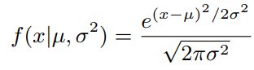

The most significant probability distribution in all statistics is **the Gaussian distribution**, sometimes known as the normal distribution or bell curve. It's crucial to grasp the definitions of "mean," "median," and "mode" in order to comprehend the normal distribution. The "mean" is the computed average of all values, the "median" is the value at the distribution's center point (mid-point) and the "mode" is the value that was seen the most frequently throughout the measurement. If a distribution is normal, the mean, median, and mode all have the same value.

* The second type is the **Bernoulli distribution** whose probability mass function is defined as 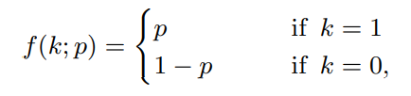 where k is an outcome.

**The Bernoulli distribution** essentially models a single trial of flipping a weighted coin. It is a kind of discrete probability distribution of a random variable because only two values are possible, *1* for the trial’s success and *0* for failure with complementary probabilities *p* and *1-p,* respectively. Therefore Bernoulli is the simplest probability distribution that exists.

**Methods**

**Epsilon-greedy**

The simplicity of the algorithm is what makes the ε-greedy method very popular. Because of this, it is considered to be a naive algorithm. In ‘greedy’ experiments, the lever with the highest known payout is always pulled except once a random action is taken. A randomly chosen arm is pulled a fraction ε of the time. The arm with the greatest known payout gets pulled the other 1-ε of the time.

**Upper confidence bound**

We require exploration since the estimations of action values are uncertain. The greedy actions appear to be the most appealing at the moment, but some of the other actions may be better. ε-greedy action selection forces the non-greedy actions to be tried, but indiscriminately, with no preference given to those that are almost greedy or particularly uncertain.

The idea of UCB is to favor the exploration of actions with a strong potential to have an optimal value. This procedure may be approached in two ways: the first one is to decrease the parameter ε over time. The second one is to be optimistic when it comes to alternatives with high uncertainty and thus preferring actions for which you haven’t had a value estimation yet.

**Boltzmann exploration**

While exploring, the agent creates an action distribution. According to the data acquired by the agent, this distribution **defines how optimal an action is**. The action distribution may be defined as the agent's belief about the best course of action.

The initial action distribution is partitioned by the temperature parameter in the Boltzmann policy implementation. As a result, the Boltzmann policy transforms the agent's exploratory behavior into a spectrum ranging from taking the action at random (random policy) to always picking the most optimum action (greedy policy).

**Gradient Bandit with softmax action preference**

Considers learning a numerical preference Ht(a) for each action *a*. The larger the preference, the more often that action is taken, but the preference has no interpretation in terms of reward. Only the relative preference of one action over another is important; if we add 1000 to all the preferences there is no effect on the action probabilities, which are determined according to a soft-max distribution (Boltzmann/Gibbs).

Initially, all preferences are the same (e.g., H1(a) = 0, ∀ a) so that all actions have an equal probability of being selected. There is a natural learning algorithm for this setting based on the idea of ***stochastic gradient ascent***. On each step, after selecting the action At and receiving the reward Rt, the preferences are updated by: 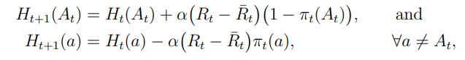 (1)

where α > 0 is a step-size parameter, and $\overline{R_{t}}$ ∈ R is the average of all the rewards up through and including time t, which can be computed incrementally. The $\overline{R_{t}}$ term serves as a baseline with which the reward is compared. If the reward is higher than the baseline, then the probability of taking At in the future is increased, and if the reward is below baseline, then the probability is decreased. The non-selected actions move in the opposite direction.

In exact gradient ascent, each preference Ht(a) would be incrementing proportional to the increment’s effect on performance: 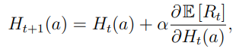 (2)

where the measure of performance here is the expected reward: 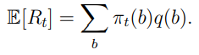

Of course, it is not possible to implement gradient ascent exactly in our case because by assumption we do not know the q(b), but in fact, the updates of our algorithm (1) are equal to (2) in the expected value, making the algorithm an instance of *stochastic gradient ascent*.

**NORMAL DISTRIBUTION** - Source.cpp

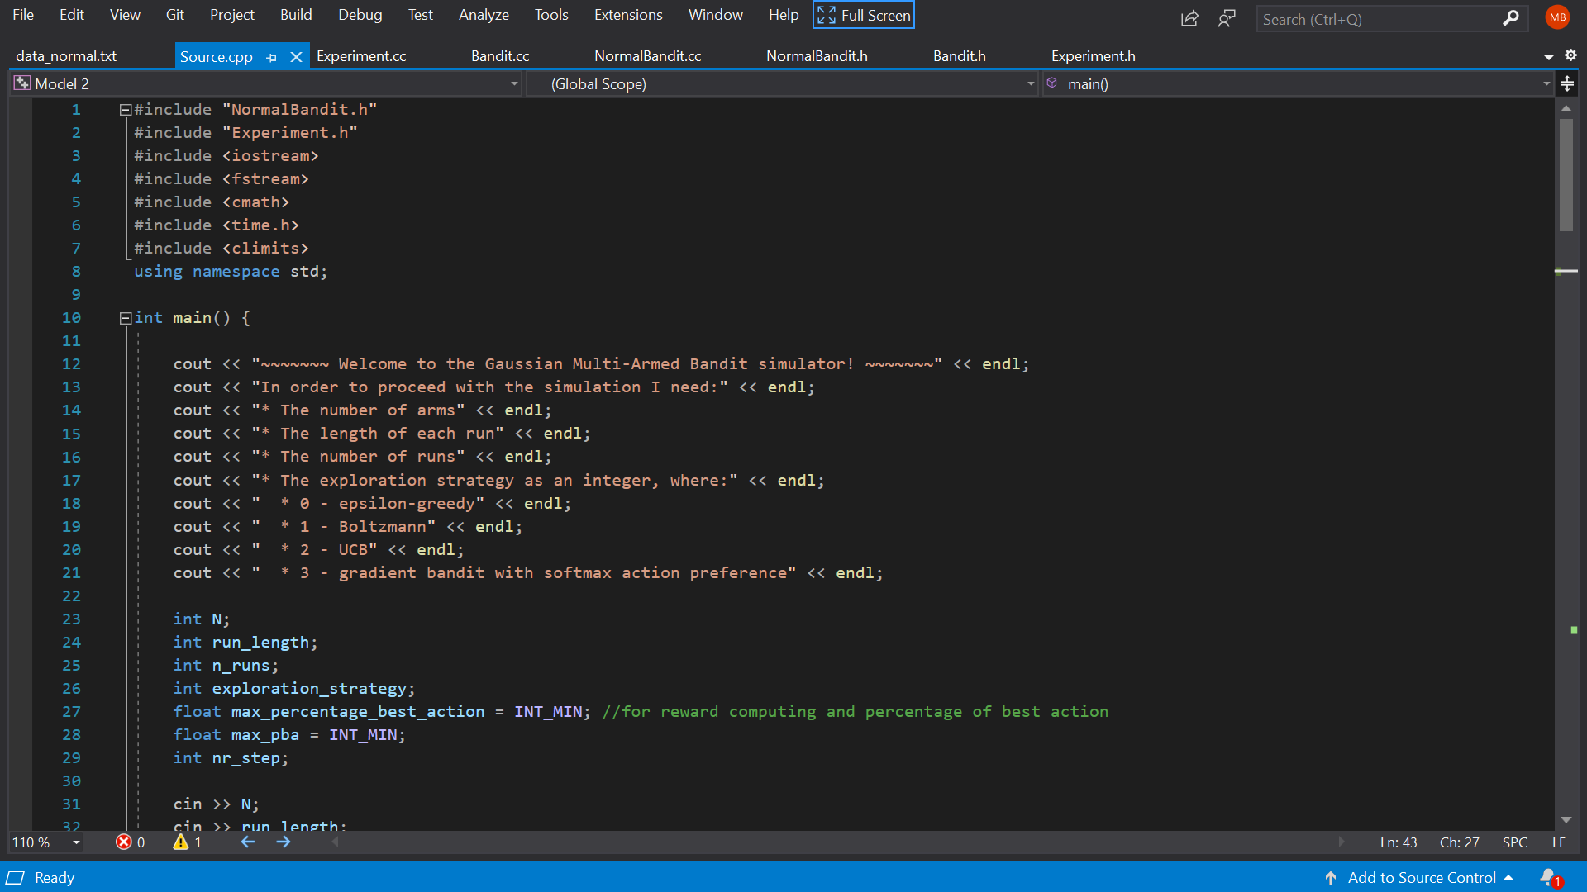

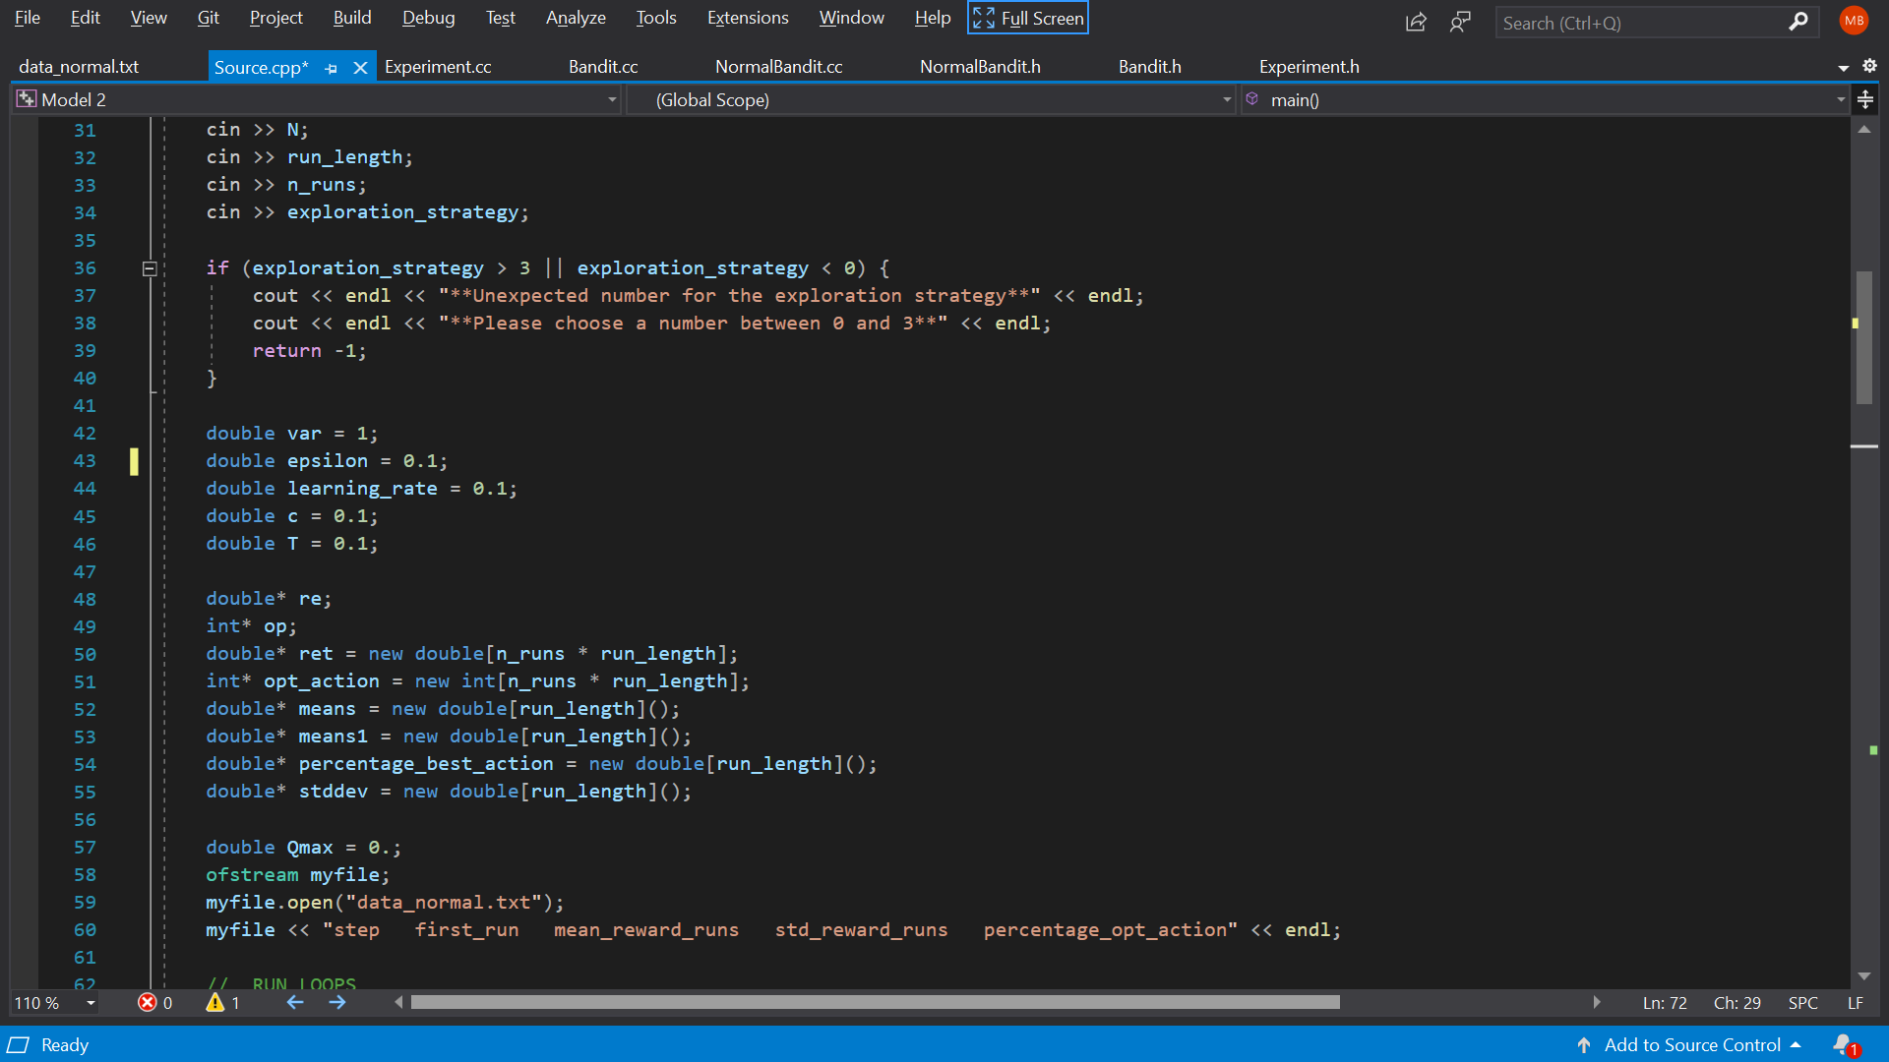

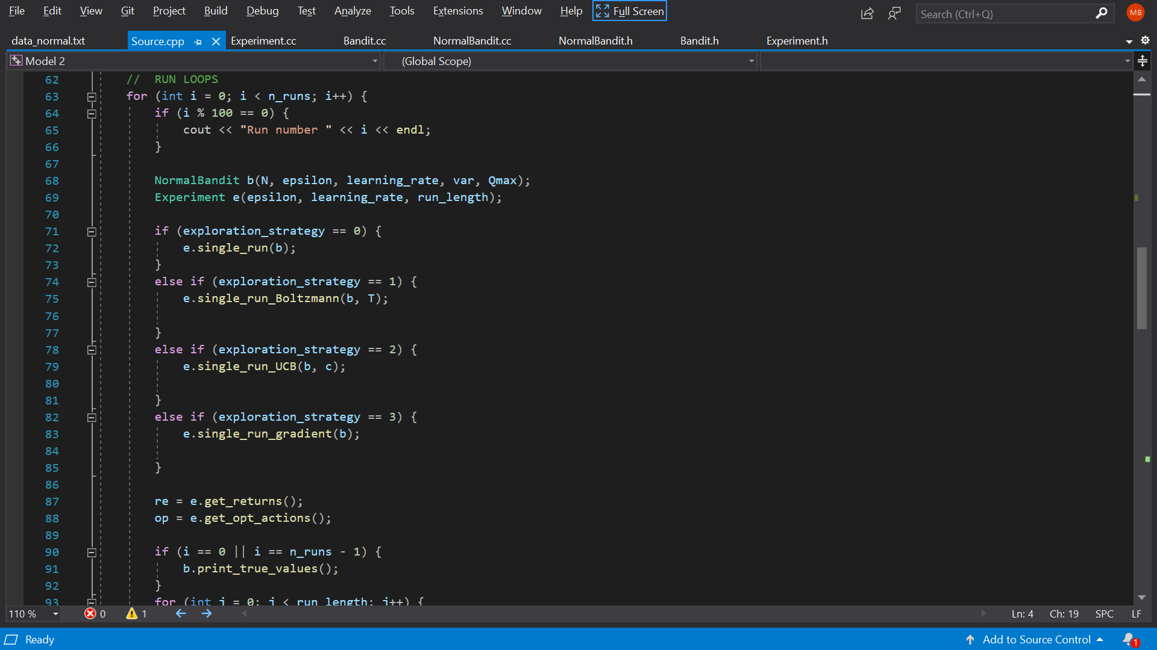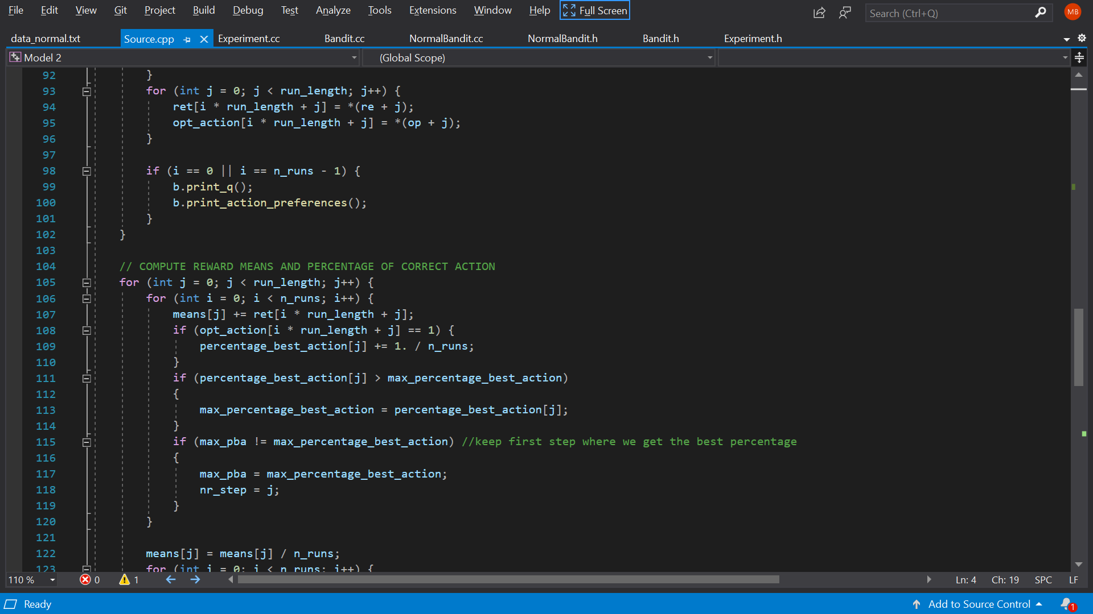

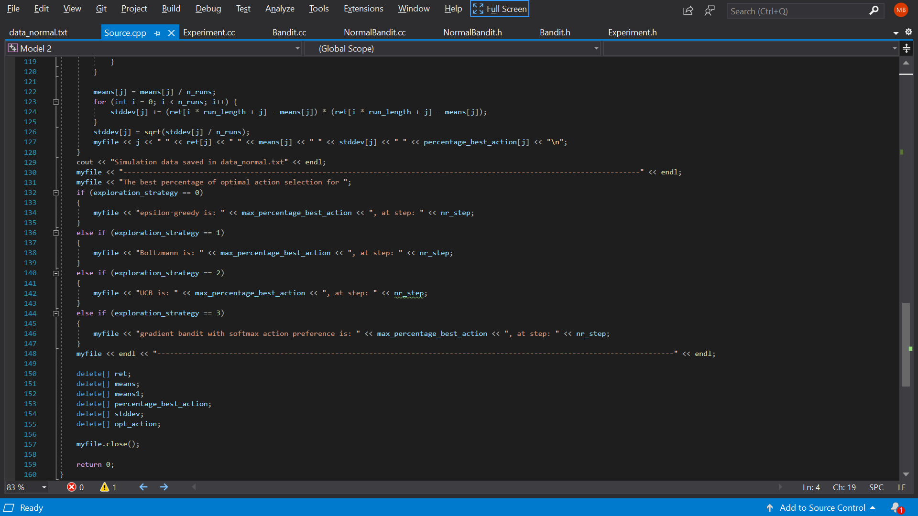

**BERNOULLI DISTRIBUTION** – Source.cpp

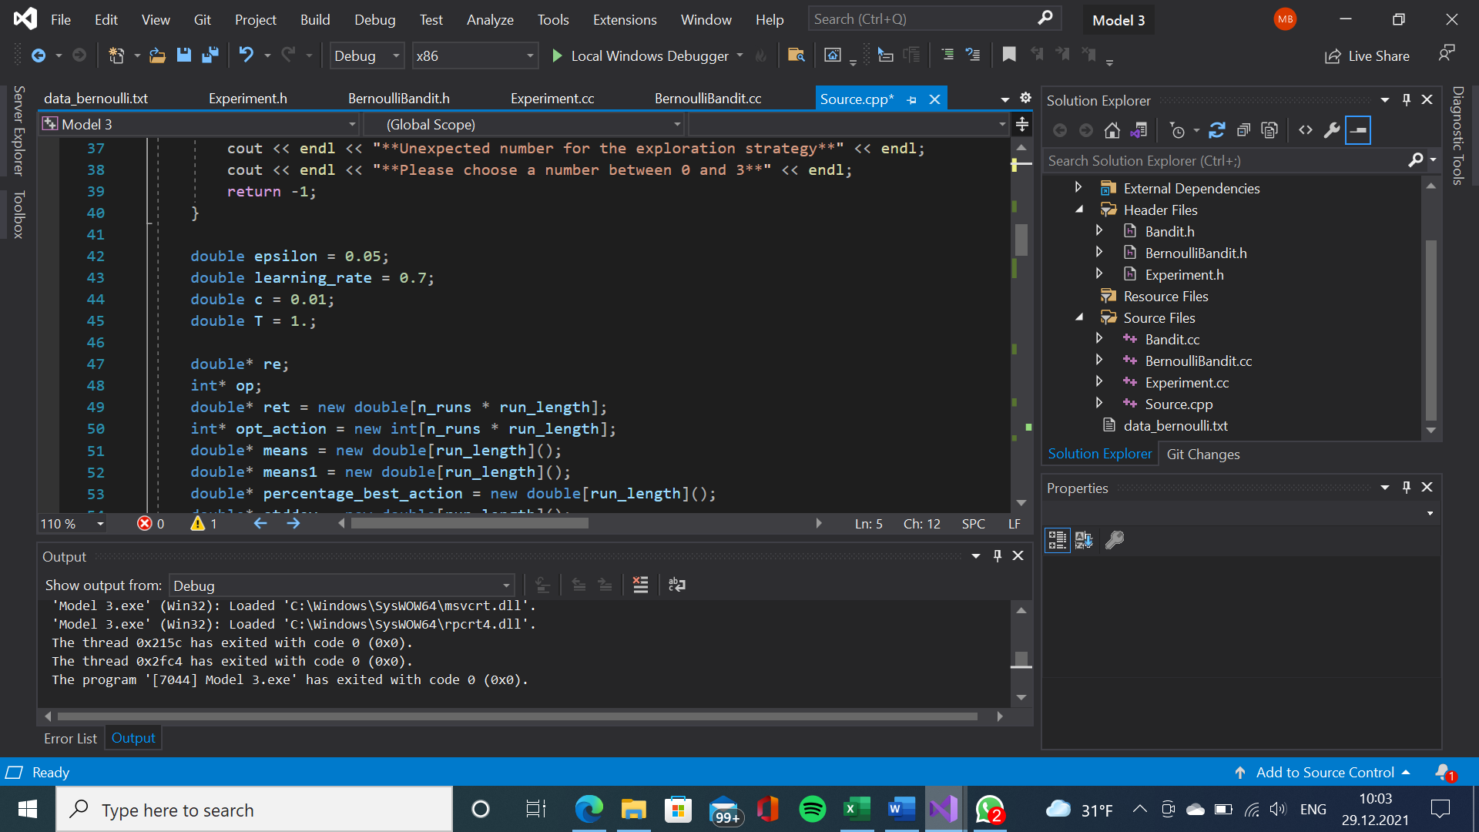

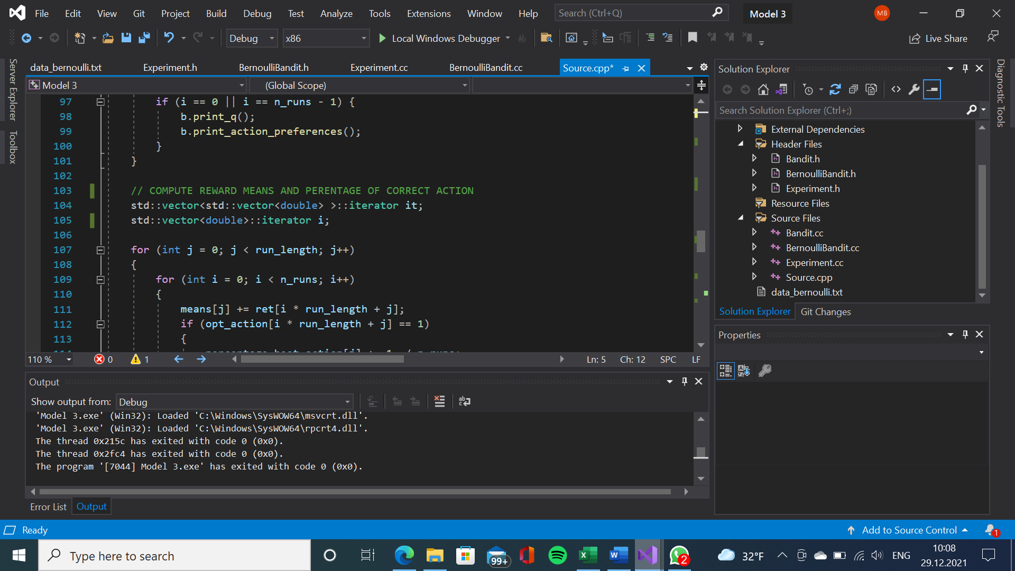

**LEGEND**

**Source.cpp**

* N= number of arms (for each slot machine)
* run_length= length of each run (number of slot machines?)
* n_runs= number of runs (plays/action selections/time steps)
* exploration_strategy:
  + 0 - epsilon-greedy
  + 1 - Boltzmann
  + 2 – UCB (Upper-Confidence-Bound Action Selection)
  + 3 - gradient bandit with softmax action preference
* var= reward variance (Gaussian distributed noise term/measure of the uncertainty in the estimated value of the action)
* epsilon (epsilon-greedy: small probability ε to select randomly from amongst all the actions with equal probability independently of the action-value estimate)
* c= confidence level
* re= rewards/returns (re = e.get_returns();)
* op (op = e.get_opt_actions();)
* opt_action= optimal action
* means= mean reward given – the true value of that action
* percentage_best_action
* Qmax= estimated value of that action converged to near certainty

**Gaussian Simulator – Brief description**

**NormalBandit.cc**

* q[a]= the true actual value of the action *a*
* Qt[a]= the estimated value of the action on the t-th time step
* Nt[a]= number of times action *a* has been chosen prior to the t-th time step (nt[i] = 0;)

q[i] = Qmax;

**Explanation:**

“As Nt (a) → ∞, by the law of large numbers, Qt (a) converges to q(a).” **(Sutton, Barto, 2014, 2015, p.34)**

“in the limit as the number of plays increases, every action will be sampled an infinite number of times, guaranteeing that Nt(a) → ∞ for all a, and thus ensuring that all the Qt(a) converge to q(a). This of course implies that the probability of selecting the optimal action converges to greater than 1 − ε, that is, to near certainty.” **(Sutton, Barto, 2014, 2015, p.34)**

**Bandit.cc**

int Bandit::take_action()

**Explanation:** “Greedy action selection always exploits current knowledge to maximize immediate reward; it spends no time at all sampling apparently inferior actions to see if they might be better. A simple alternative is to behave greedily most of the time, but every once in a while, say with small probability ε, instead to select randomly from amongst all the actions with equal probability independently of the action value estimates” **(Sutton, Barto, 2014, 2015, p.34)**

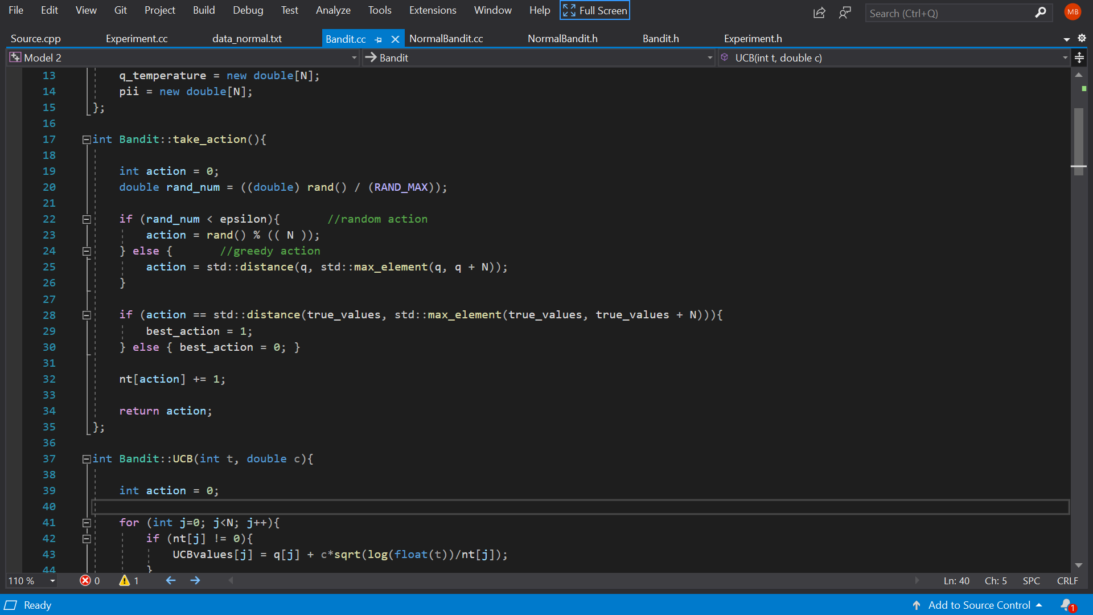

int Bandit::UCB

Selects among the non-greedy actions according to their potential for actually being optimal, taking into account both how close their estimates are to being maximal and uncertainties in those estimates.

**Explanation:** “ One effective way of doing this is to select actions as

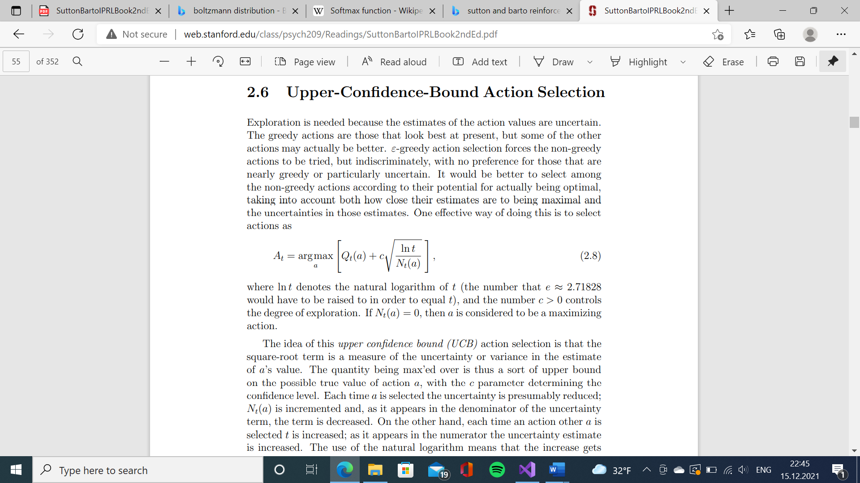

where ln t denotes the natural logarithm of t (the number that e ≈ 2.71828 would have to be raised to equal t), and the number c > 0 controls the degree of exploration.” **(Sutton, Barto, 2014, 2015, p.41)**

“The idea of this upper confidence bound (UCB) action selection is that the square-root term is a measure of the uncertainty or variance in the estimate of a’s value.” **(Sutton, Barto, 2014, 2015, p.41)**

Implementation of this formula:

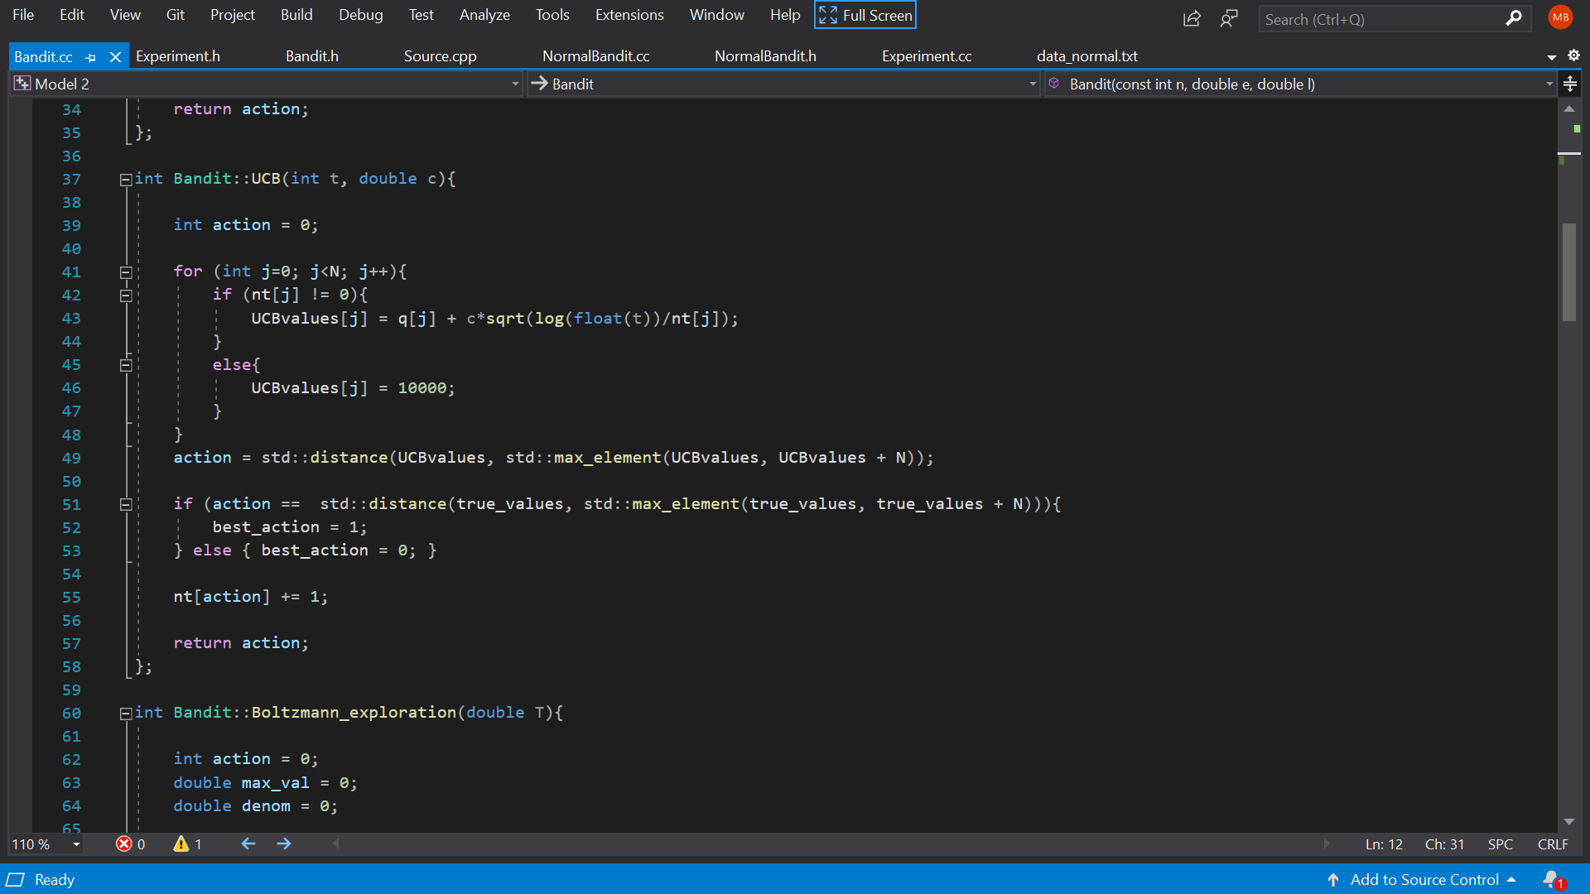

int Bandit::Boltzmann_exploration

* q_temperature[a]

*boltzmann_temperature is used to create the proper exploration policy object*

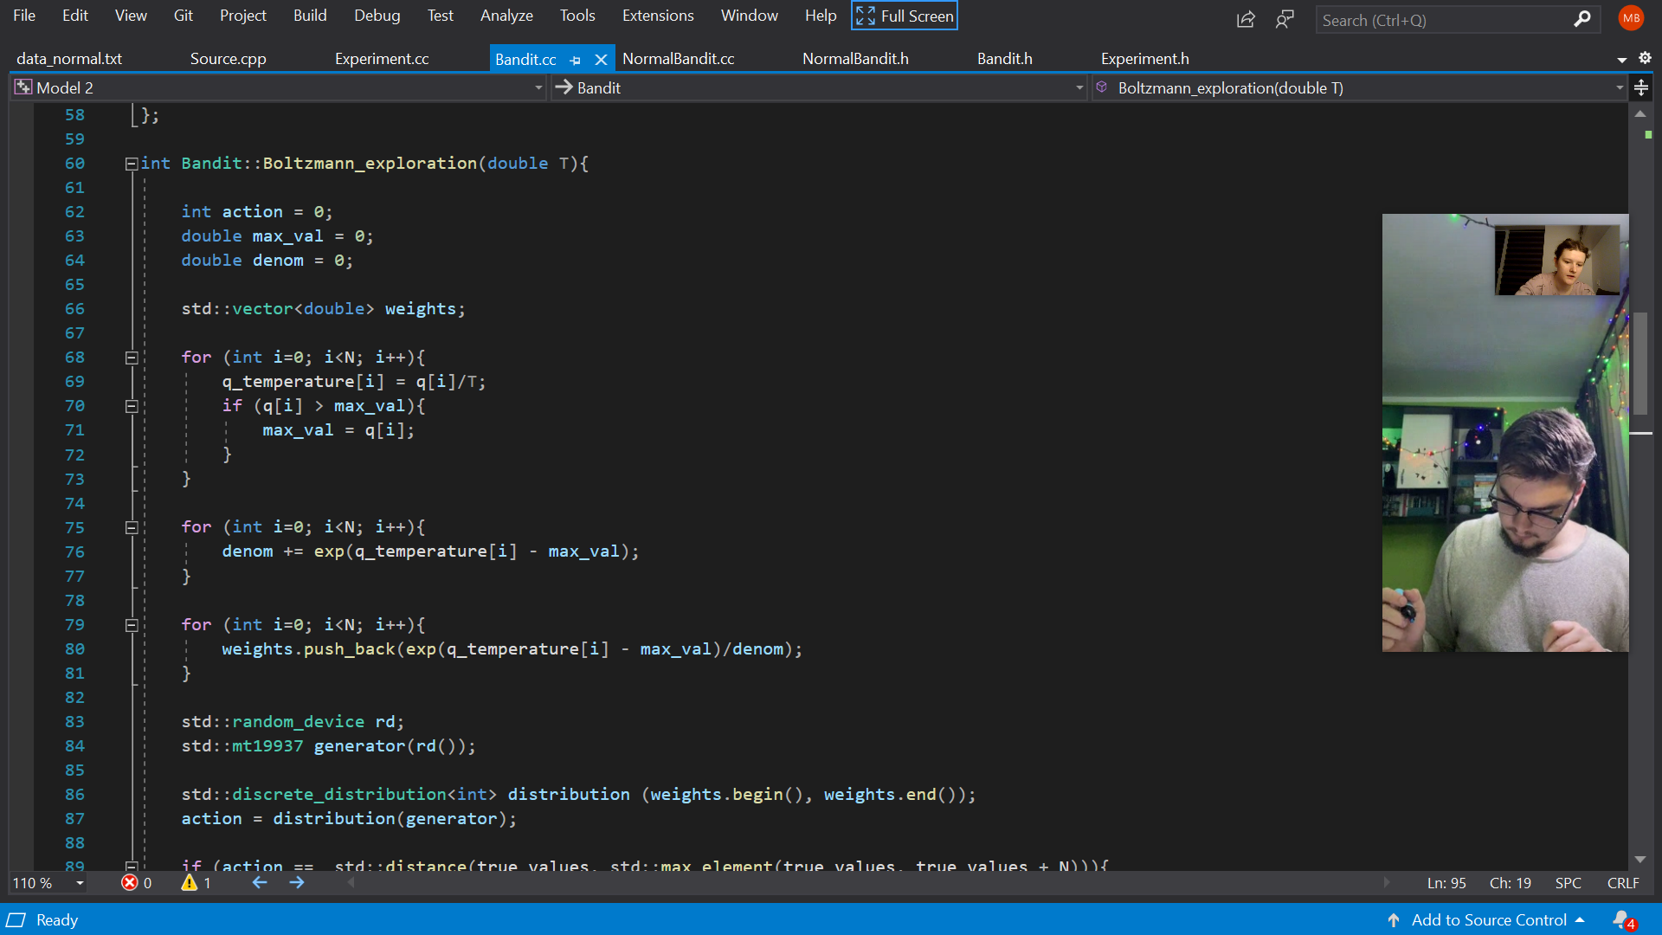

int Bandit::gradientBanditAction

Soft-max distribution:

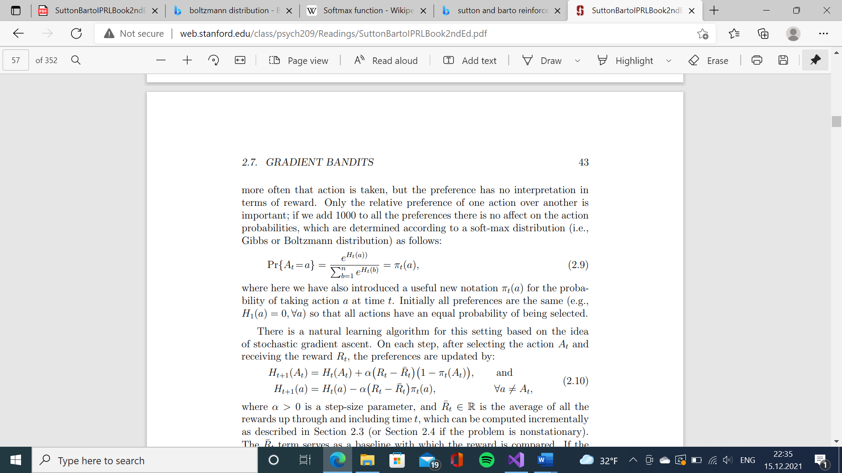

* **(Sutton, Barto, 2014, 2015, p.43)**
* πt(a)= the probability of taking an action *a* at time t (pii[i])

Implementation of this formula:



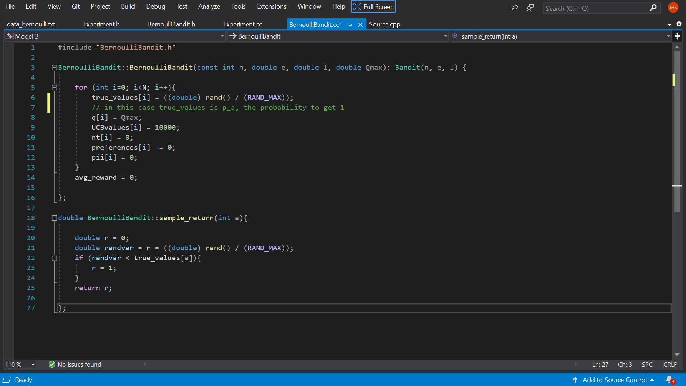**Bernoulli Simulator – Brief description - Additions**

A Bernoulli multi-armed bandit can be described as a tuple of ⟨A,R⟩⟨A,R⟩, where:

* We have K machines with reward probabilities, {θ1,…,θK}.
* At each time step t, we take an action a on one slot machine and receive a reward r.
* A is a set of actions, each referring to the interaction with one slot machine. The value of action a is the expected reward, Q(a)=E[r|a]=θ. If action at at the time step t is on the i-th machine, then Q(at)=θi.
* R is a reward function. In the case of Bernoulli bandit, we observe a reward r in a *stochastic* fashion. At the time step t, rt=R(at) may return reward 1 with a probability Q(at) or 0 otherwise.

The goal is to maximize the cumulative reward t . If we know the optimal action with the best reward, then the goal is same as to minimize the potential [regret](https://en.wikipedia.org/wiki/Regret_(decision_theory)) or loss by not picking the optimal action.

**Gaussian distribution – methods behavior**

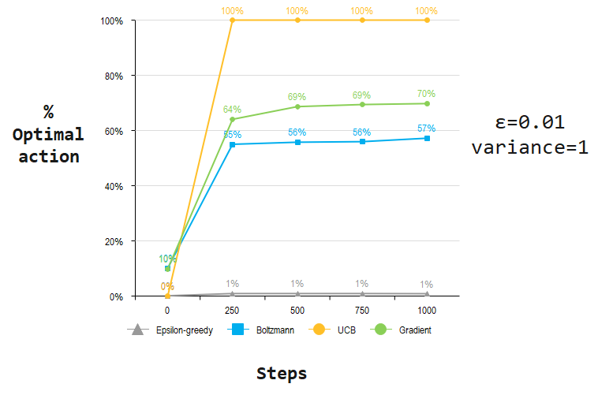

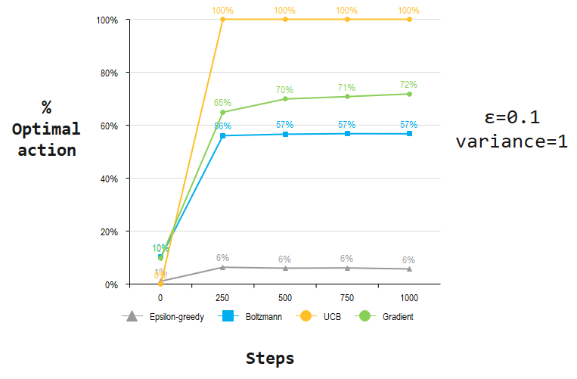

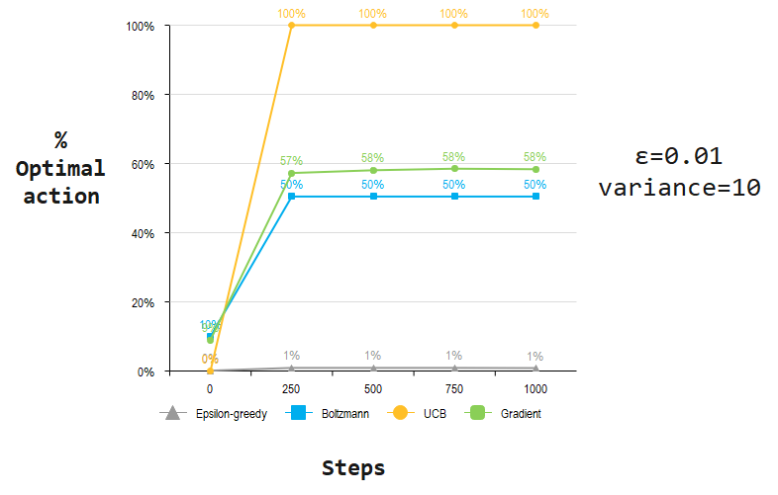

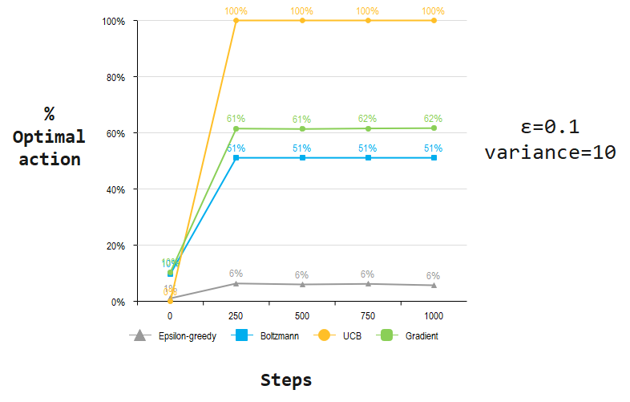

**Bernoulli distribution – methods behavior**

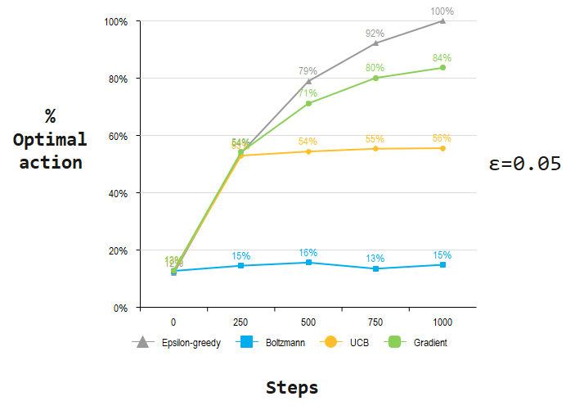

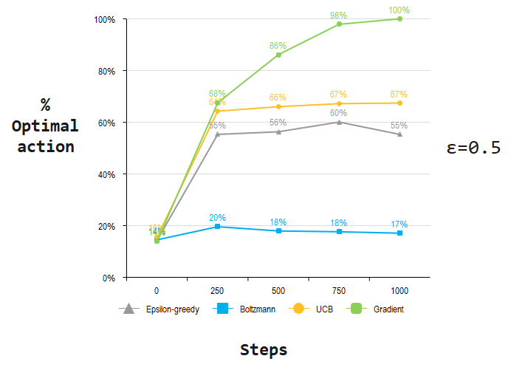

**Gaussian distribution**

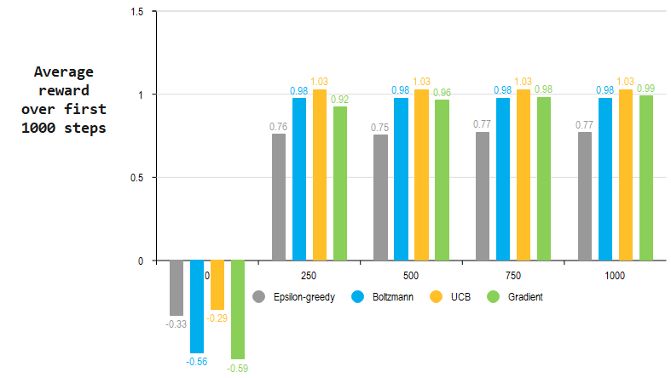

**Bernoulli distribution**

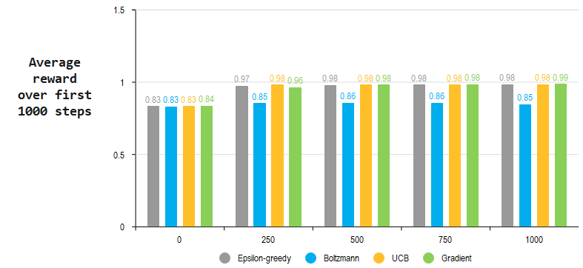

***COLLECTED DATA – 10-ARMED TESTBED***

* **PERCENTAGE OF OPTIMAL ACTION:**

|  |  |  |  |  |  |  |
| --- | --- | --- | --- | --- | --- | --- |
|  | **NORMAL DISTRIBUTION** | | |  |  |  |
|  |  |  |  |  |  |  |
| Steps | Epsilon-greedy | Boltzmann | UCB | Gradient | epsilon=0.01 | |
| 0 | 0.001 | 0.101 | 0 | 0.0985 | variance=1 | |
| 250 | 0.009 | 0.55 | 1 | 0.6405 |  |  |
| 500 | 0.009 | 0.5575 | 1 | 0.6865 |  |  |
| 750 | 0.009 | 0.5595 | 1 | 0.694 |  |  |
| 1000 | 0.0085 | 0.572 | 1 | 0.6975 |  |  |
|  |  |  |  |  |  |  |
| Steps | Epsilon-greedy | Boltzmann | UCB | Gradient | epsilon=0.1 | |
| 0 | 0.0105 | 0.1015 | 0 | 0.0985 | variance=1 | |
| 250 | 0.0635 | 0.5605 | 1 | 0.649 |  |  |
| 500 | 0.06 | 0.566 | 1 | 0.699 |  |  |
| 750 | 0.061 | 0.568 | 1 | 0.708 |  |  |
| 1000 | 0.057 | 0.5675 | 1 | 0.718 |  |  |
|  |  |  |  |  |  |  |
| Steps | Epsilon-greedy | Boltzmann | UCB | Gradient | epsilon=0.01 | |
| 0 | 0.001 | 0.0995 | 0 | 0.09 | variance=10 | |
| 250 | 0.009 | 0.5045 | 1 | 0.5725 |  |  |
| 500 | 0.009 | 0.5045 | 1 | 0.5805 |  |  |
| 750 | 0.009 | 0.5045 | 1 | 0.585 |  |  |
| 1000 | 0.0085 | 0.5045 | 1 | 0.5835 |  |  |
|  |  |  |  |  |  |  |
| Steps | Epsilon-greedy | Boltzmann | UCB | Gradient | epsilon=0.1 | |
| 0 | 0.0105 | 0.0975 | 0 | 0.1035 | variance=10 | |
| 250 | 0.0635 | 0.511 | 1 | 0.615 |  |  |
| 500 | 0.06 | 0.511 | 1 | 0.6135 |  |  |
| 750 | 0.062 | 0.511 | 1 | 0.6155 |  |  |
| 1000 | 0.057 | 0.511 | 1 | 0.6165 |  |  |
|  |  |  |  |  |  |  |

|  |  |  |  |  |  |  |
| --- | --- | --- | --- | --- | --- | --- |
|  | **BERNOULLI DISTRIBUTION** | | |  |  |  |
|  |  |  |  |  |  |  |
| Steps | Epsilon-greedy | Boltzmann | UCB | Gradient | epsilon=0.05 | |
| 0 | 0.0925 | 0.0985 | 0.099 | 0.1005 |  |  |
| 250 | 0.4175 | 0.1125 | 0.4105 | 0.42 |  |  |
| 500 | 0.6115 | 0.121 | 0.4215 | 0.5515 |  |  |
| 750 | 0.7145 | 0.1045 | 0.429 | 0.6205 |  |  |
| 1000 | 0.775 | 0.115 | 0.4305 | 0.648 |  |  |
|  |  |  |  |  |  |  |
| Steps | Epsilon-greedy | Boltzmann | UCB | Gradient | epsilon=0.5 | |
| 0 | 0.091 | 0.0925 | 0.099 | 0.0885 |  |  |
| 250 | 0.353 | 0.125 | 0.4105 | 0.431 |  |  |
| 500 | 0.3595 | 0.1145 | 0.4215 | 0.55 |  |  |
| 750 | 0.3835 | 0.1125 | 0.429 | 0.625 |  |  |
| 1000 | 0.353 | 0.109 | 0.4305 | 0.6385 |  |  |

* **AVERAGE REWARD OVER FIRST 1000 STEPS:**

|  |  |  |  |  |  |  |  |
| --- | --- | --- | --- | --- | --- | --- | --- |
|  | **NORMAL DISTRIBUTION** | | | | | | |
|  |  |  |  |  |  |  |  |
| Steps | Epsilon-greedy | Boltzmann | UCB | Gradient | epsilon=0.1 | |  |
| 0 | -0.329502 | -0.555168 | -0.292764 | -0.593066 | variance=1 | |  |
| 250 | 0.757754 | 0.975126 | 1.02819 | 0.923992 |  |  |  |
| 500 | 0.75364 | 0.975722 | 1.02819 | 0.964808 |  |  |  |
| 750 | 0.772994 | 0.976436 | 1.02819 | 0.98264 |  |  |  |
| 1000 | 0.768973 | 0.977211 | 1.02819 | 0.988443 |  |  |  |
|  |  |  |  |  |  |  |  |
|  | **BERNOULLI DISTRIBUTION** | | | | | | |
|  |  |  |  |  |  |  |  |
| Steps | Epsilon-greedy | Boltzmann | UCB | Gradient | epsilon=0.05 | |  |
| 0 | 0.831778 | 0.830985 | 0.831959 | 0.835585 |  | |  |
| 250 | 0.972155 | 0.85167 | 0.981062 | 0.963125 |  |  |  |
| 500 | 0.979293 | 0.855404 | 0.981721 | 0.980347 |  |  |  |
| 750 | 0.979803 | 0.856443 | 0.981095 | 0.982872 |  |  |  |
| 1000 | 0.983477 | 0.845939 | 0.982871 | 0.985924 |  |  |  |

# Discussions

***Commenting on Graphic Representations of collected data***

Now it’s time to answer the question we asked ourselves from the beginning:

***Which of these strategies is the most effective?***

Despite the fact that this is a tough issue to answer in general, we can run them all on the 10-armed testbed and compare their results. The fact that they all have a parameter complicates things; in order to provide a meaningful comparison, we will have to consider their performance as a function of their parameter.

So far, our graphs have illustrated the progression of learning over time for each algorithm and parameter setting, but showing such a learning curve for each algorithm and parameter value would be too visually confusing. Instead, we summarize a complete learning curve by the average results of optimal action choice and rewards collected over the first 1000 steps.

* ***Percentage of optimal action selection***

As shown in the graphs above, in the case of ***Gaussian distribution***, the modification of **probability ε** and **variance in the selection of the action values** determines the variation in the optimal choice of an action, but the ranking of the methods according to performance remains unchanged, the **Upper-Confidence-Bound** action selection strategy being the most efficient. Thus, on the 10-armed testbed, it seems pretty clear which method has the best chance of choosing an optimal action.

In terms of ***Bernoulli distribution***, from testing, we notice that an algorithm that is optimal in the first 250 turns can be outperformed by another algorithm in the long term. When epsilon has a lower value (*ε=0.05*), the ε-greedy exploration strategy tends to perform best of all methods but is followed closely by Gradient Bandit with SoftMax action preference and UCB in the first 250 steps. When epsilon is bigger (*ε=0.5*) the Gradient Bandit behaves optimally, ε-greedy falling in third place. So in order to choose the optimal method, **one must consider whether optimal results are desired in the long or short term** for the problem in cause.

When evaluating a method, we should consider not only how well it performs at its optimal parameter setting, but also how sensitive it is to the value of the parameter. These methods are all fairly insensitive, performing well throughout a range of parameter values varying by about an order of magnitude.

* ***Average reward over first 1000 steps***

If we draw a parallel between the two distributions, the discrepancy between the reward collected initially stands out. For the Gaussian model, all methods start at negative mean rewards, but there is a jump to positive values that for some strategies, such as UCB, even **exceed** the rewards collected in the Bernoulli simulation.

For the aforementioned distribution, we follow a ***constant and controlled path of collecting rewards***. Each action has an expected mean reward that starts from good values but does not signal a significant increase, not overtaking the verge of 1.

It both cases, it is noticeable a strategy whose rewards are lower, compared to the rest of the exploration methods that exhibit fairly close values. These are epsilon-greedy for the Gaussian simulation and Boltzmann for the Bernoulli simulation.

We already know that ε-greedy is a standard approach but not the most effective one since it explores randomly, but **Boltzmann does not rank that high** in terms of the optimal choice percentage (being second to last or worse) or regarding the rewards given either (since they do not register much growth over time). The observations down below might clear up what are some causes for this somewhat poor performance.

***Boltzmann Observations***

If we specify a very small temperature value, the differences between original action probabilities become more substantial, so the action with the highest probability is even more likely to be selected. When the temperature parameter is near zero, the Boltzmann policy becomes a greedy policy since the most likely action is always chosen.

The original action distribution, on the other hand, is dominated by a large value of the temperature parameter. As a result, the probabilities are nearly identical, and we end up with a random policy.

# Conclusions

While an analysis of many distributions would be needed to draw broader conclusions, the two distribution types we implemented had little impact on performance. It may be that Gaussian and Bernoulli distributions give similar results as the repeated sampling of a Bernoulli distribution is a binomial distribution, which is essentially a discrete Gaussian. **Different results may be obtained using other distributions, such as the exponential.**

In comparison to the Gaussian distribution simulation model, the exploration strategies in the Bernoulli distribution simulator **run substantially quicker** in the 10-armed testbed. This is an indicator for determining which distribution is more efficient in terms of execution time.

As can be seen, the standard deviation for the algorithms under the Gaussian distribution is much larger than that of the Bernoulli. The Gaussian's **continuous nature** is a potential cause for this difference. This leads to a higher chance that small sample size will result in an average that is much less than expected. If this happens to the best arm, it is likely to converge to a different arm in epsilon-greedy, especially if epsilon is decaying quickly.

When it comes to Gradient Bandit with SoftMax action preference, there is a much smaller chance that the best arm is chosen, so in order to correct the initial bias, there will be needed a lot more trials. For epsilon greedy, this can be solved through a slower decay, at the cost of longer convergence times. In the case of Softmax, attempting to reduce this likelihood will result in worse convergence due to the arms having more equal probability.

Although the strategies explored may be the best we can do at present, they are far from a fully satisfactory solution to the problem of balancing exploration and exploitation.

But despite their simplicity, the approaches provided in this paper are, in our opinion, **deemed the state of the art**. There are more sophisticated methods, but their *complexity and assumptions* make them impractical for the reinforcement learning problem.

# References

Here are the resources we have used in researching the subject to better understand the chosen topic and what are some ways to approach the Bandit problem:

* *Reinforcement Learning: An Introduction (Sutton, R., S., Barto, A., G., 2014, 2015)*

[SuttonBartoIPRLBook2ndEd.pdf (stanford.edu)](http://web.stanford.edu/class/psych209/Readings/SuttonBartoIPRLBook2ndEd.pdf)

* [The Multi-Armed Bandit Problem and Its Solutions (lilianweng.github.io)](https://lilianweng.github.io/lil-log/2018/01/23/the-multi-armed-bandit-problem-and-its-solutions.html#case-study)
* [Solving the Multi-Armed Bandit Problem | by Anson Wong | Towards Data Science](https://towardsdatascience.com/solving-the-multi-armed-bandit-problem-b72de40db97c)
* [How to Build a Product Recommender Using Multi-Armed Bandit Algorithms - OfferZen](https://www.offerzen.com/blog/how-to-build-a-product-recommender-using-multi-armed-bandit-algorithms)
* [Reinforcement Learning: Multi-Armed Bandit | Medium](https://markelsanz14.medium.com/introduction-to-reinforcement-learning-part-1-multi-armed-bandit-problem-618e8cbf9d4b)
  + [part1-MultiarmedBandit.ipynb - Colaboratory (google.com)](https://colab.research.google.com/drive/1oqn00G-A4s_c8n6FoVygfQjyWl6BKy_u#forceEdit=true&offline=true&sandboxMode=true)
* [Your Client Engagement Program Isn't Doing What You Think It Is. | Stitch Fix Technology – Multithreaded](https://multithreaded.stitchfix.com/blog/2018/11/08/bandits/)
* [Bandit Algorithms (tor-lattimore.com)](https://tor-lattimore.com/downloads/book/book.pdf)
* [Reinforcement Learning Introduction | Mosaic Data Science Blog](https://mosaicdatascience.com/2019/07/17/reinforcement-learning-intro-multiarmed-bandits-1/)
* [How Solving the Multi-Armed Bandit Problem Can Move Machine Learning Forward – The New Stack](https://thenewstack.io/how-solving-the-multi-armed-bandit-problem-can-move-machine-learning-forward/)
* [Multi-Armed Bandits: Exploration versus Exploitation (stanford.edu)](https://web.stanford.edu/class/cme241/lecture_slides/MultiArmedBandits.pdf)
* [MAB-Survey.pdf (umich.edu)](http://web.eecs.umich.edu/~teneket/pubs/MAB-Survey.pdf)
* [Multi_Arm_Bandit_final_report.pdf (arizona.edu)](https://www.math.arizona.edu/~gabitov/teaching/181/math_485/Final_Report/Multi_Arm_Bandit_final_report.pdf)
* [Multi-armed bandit and Thompson Sampling in C++ and Python | gcardone’s blog](https://www.gcardone.net/2019-04-02-thompson-sampling/)
* [Using Boltzmann distribution as the exploration policy in TensorFlow-agent reinforcement learning models | Bartosz Mikulski (mikulskibartosz.name)](https://www.mikulskibartosz.name/using-boltzmann-distribution-as-exploration-policy-in-tensorflow-agent/)
* [Gaussian Distribution - an overview | ScienceDirect Topics](https://www.sciencedirect.com/topics/biochemistry-genetics-and-molecular-biology/gaussian-distribution)
* [Gaussian Distribution Definition | DeepAI](https://deepai.org/machine-learning-glossary-and-terms/gaussian-distribution)
* [5.pdf (wustl.edu)](https://www.cse.wustl.edu/~garnett/cse515t/fall_2019/files/lecture_notes/5.pdf)
* [Bernoulli Distribution | Brilliant Math & Science Wiki](https://brilliant.org/wiki/bernoulli-distribution/)
* [Bernoulli Distribution: Definition, Equations & Examples | Study.com](https://study.com/academy/lesson/bernoulli-distribution-definition-equations-examples.html)
* [GitHub - nicoleorzan/Multi-armed-bandit-RL: C++ implementation of Multi-Armed Bandits (Gaussian and Bernoulli)](https://github.com/nicoleorzan/Multi-armed-bandit-RL)